Define the Problem
The engineering design project assignment asked students to identify a problem on campus or in society overall, to propose a solution to the issue, and to work with a team to develop a prototype. The design project had three limitations: cost, expenses could be at most $20.00; time, the report, presentation, and prototype had to be finalized and submitted within four weeks; and teamwork, each member had to contribute work to the production process. The group was also required to work as a professional engineering team and to appoint clear roles and work to each member.

Gather Information
Several considerations taken into account for this design project. Globally and socially, the team took into consideration the various target audiences of the product. The target audience of the cell phone case was the faculty and students at Virginia Tech. Other possible consumers would be other college populations, and any person who needs a card to swipe for access, or wants easy access to a generic wallet-sized card. The prototype was designed for an iPhone, because this iPhone generation appeared to be the most popular smartphone amongst college students. According to a poll conducted on STEP Group C, 63.63 % of students have an iPhone, 33.33% of students have an Android, and 3% of students have a phone that is neither iPhone nor Android. Based on these statistics, the prototype was designed to be used for an iPhone, specifically the iPhone 4s*. Nationally, Android has more users than Apple, but based on the primary audience, college students, the team designed the first prototype around an iPhone. The actual aesthetic design of the phone case was also based around the target audience at Virginia Tech. However, the design printed on the case could be easily varied to best please the audience. The team also observed economic considerations when discussing the product. The phone case was designed to use as little material as possible while still being effective as a card carrier and a protective phone case. This would cut costs for the manufacturer, while ensuring a good profit as students generally pay more for phone accessories than they might other products. The team briefly discussed environmental concerns, but did not take them into great consideration.

Generate Multiple Solutions
The first step of the design process was brainstorming a problem around the Virginia Tech campus that needed solving. Society has many flaws that affect numerous persons and have no quick solution; these problems are too broad and arguable. Therefore, the team determined that a solving a problem on campus was both more achievable than deciding on a problem in society. The team also appreciated the fact that solving a problem on campus would be beneficial to the team and other students. Because the team is part of the Virginia Tech population, there was much discussion of the little issues that the individual team members faced on a day to day basis. One of the subjects that was talked about by the entire team involved the Virginia Tech identification card, the Hokie Passport.
The Hokie Passport is a plastic wallet-sized card that is used by students and faculty for everything from meals at the cafeterias to access to the dorms. Currently, the Passport is popularly carried in wallets or attached to a lanyard. However, the card is used so often that having to pull it out of a wallet or find the lanyard in a backpack is inconvenient. There was some discussion on different types of wallets that would eliminate the need to remove the card from a card slot; however, that solution did not satisfy the entire consumer base as not every client carries a wallet. Also, if for any reason the client did not have their wallet, the client really could not function on campus. There was more discussion on lanyard solutions, but the group came to the consensus that consumers dislike lanyards in general and likely would not purchase a new one.
The one item that every group member was carrying at the time of the brainstorming discussion was a phone. The group decided that the best and most obvious solution to the Hokie Passport problem was a phone case that would carry the card. The phone case had to not only hold the Passport, as there exist phone cases that incorporate card storage, but needed to include some function that allowed the Passport to be swiped without being removed from the phone case.
There were several different types of functions that were immediately thought of and easily explained. One solution involved the 360 degree rotation of the card on a support piece. Another suggested that the card be flipped so that it was perpendicular to the back of the phone. A simpler proposition called for a piece that would slide the card lengthwise off the side of the phone just enough that it could be swipe. The final design idea combined all three of the previous ideas by sliding the card vertically up the back of the phone, flipping the card out from the top of the phone case, and rotating the card around 180 degrees. During this portion of the design process, the team utilized an iPhone 4s, a Hokie Passport, and an Otterbox phone case as visual aids.
Analyze and Select a Solution
The design matrix proved to be the most helpful tool in determining the final product design. Criteria of the phone case was divided into five different categories: appearance, cost, effectiveness, protection, and ergonomics. After much debate and discussion, each category was assigned a different amount of points which ultimately added up to one hundred. Appearance of the phone case was assigned the most points at 35, because the group determined that the consumer base will often buy a phone case based mainly on the aesthetics of the case. The next two categories, Effectiveness and Ergonomics, tied at 20 points each. Because many future sales of the phone case will be based off of word-of-mouth, the phone case must actually work well and the client must like the way the phone case feels in their hands for good reviews. The next category was Cost, with 15 points. The group set Cost at a lower value than other products may consider, because phone cases are generally cheap to make, satisfying the manufacturer, and the consumer base is known to often spend a lot of money on electronic accessories. The last category at 10 points was Protection, because while the phone needs to be protected by the case, the first and foremost function of the phone case is to allow easy access to the Hokie Passport.
When applying the design matrix to the four different proposed case designs, the team carefully debated every criteria based on both personal and professional preference. Before the team completed the design matrix, the most popular design was the phone case that would allow the card to be flipped out perpendicularly to the back of the case. However, this case was rated at a low 57%. The team determined the protection would be low as the card appendage would be easily broken if the phone was dropped, despite the ergonomics gaining the highest rating of the four designs. The phone case with the flip out and rotation option was only slightly better rated at 58%, because the bulky mechanics needed to perform the necessarily actions would be the most expensive and would not be aesthetically pleasing. The more simple 360 degree flat rotation design scored a 70%, as the phone case would be slim and user-friendly, contributing to high appearance and effectiveness scores. The winning phone case design received a score of 74.5%. This phone case was the simplest design, with an appendage that held and slid the card in and out of a pocket on the back of the case. As such, the phone case would appear as a single piece, allowing for highly rated appearance and the simple mechanics allowed the case to be extremely cost-efficient and effective.
The team took some time to consider ethical implications of the phone case design, and could not determine any major problems. The only possible concerns would be environmental, as the phone case would be mass produced and made out of plastic. However, given enough time and research, more environmentally friendly materials could be created and used.
The team also considered the general usefulness of this type of phone case in society outside of Virginia Tech. Since the Hokie Passport operates similarly to a credit card or any other key card, there would likely be a high global application of the design. The main issue of the phone case was that the case was designed to hold only one card, so the case would not be a replacement for a wallet. However, this problem would be overlooked as it negates the need to pull out a wallet in order to access a swipe card, which is the largest reason for carrying a wallet.

Test and Implement a Solution
The final design of the phone case was 3D printed into three plastic pieces that were superglued together, as seen in Picture 1. The first piece was the main phone case. This piece held the phone and had various openings to allow access to the power and volume buttons, and phone camera. The second piece was a mount. It served as a spacer between the first and third pieces, and as the pocket dimensions for the Hokie Passport. The third and final piece closed the card pocket. This piece had an oval opening in the center of the card pocket, to allow the user to manually push and pull the card into the pocket for use.
This prototype is different from the original design. The first design called for a fourth sliding piece that would hold the card and be mounted on some type of sliding ridges. However, during the CADing of the design, the complexities of that design and the time limitation restricted the exact design from being created. However, the final design works well to serve the design’s function, and calls for less material.
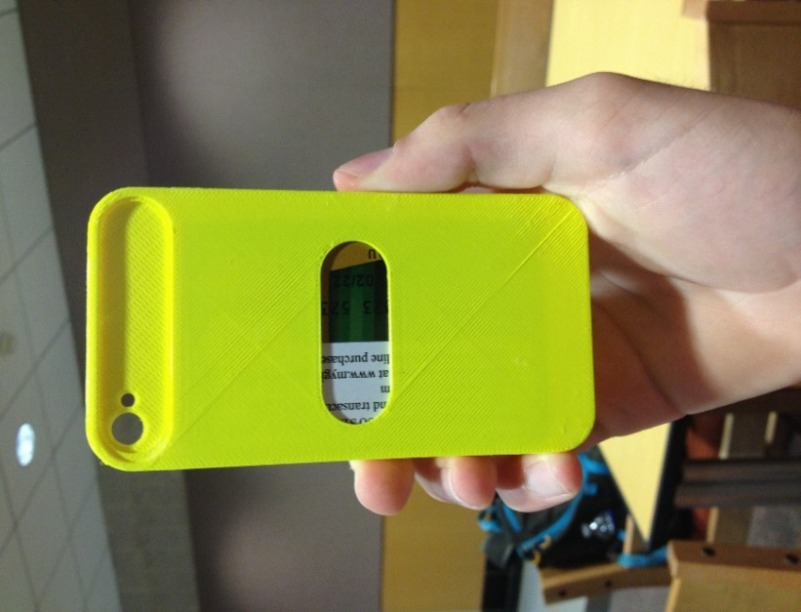
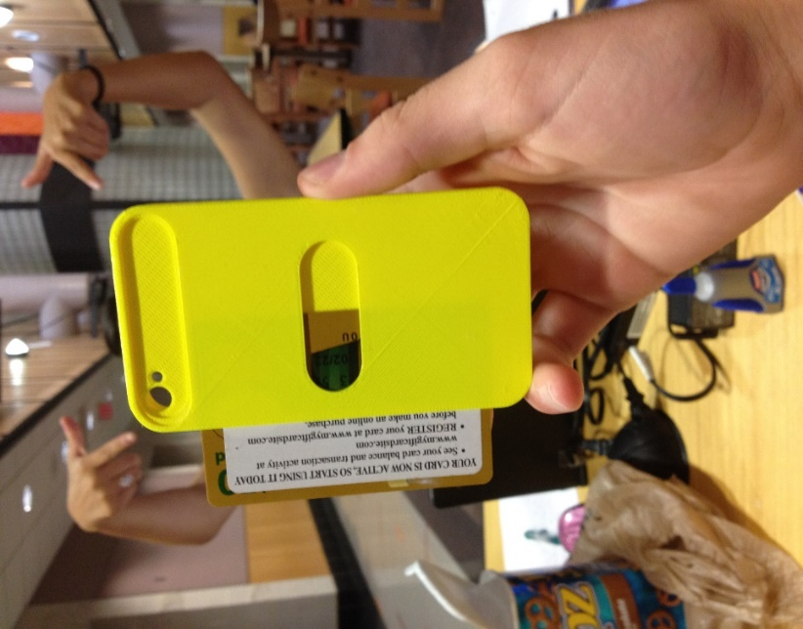
Picture 1 Design prototype glued together Picture 2 Card manually slid out of prototype
The phone case design had two functions: one, to allow easy access to a Hokie passport or other swipe card, and two, to store the card when not in use.
The prototype was first tested for the second function. A credit card was slid into the card pocket, which matched the dimensions of the card perfectly. The case was held so that the card pocket opening faced the ground. The card generally stayed in the case, however, during a few tests the card fell out. When shaken, the card fell out of the pocket easily. The card also slid out of the case at other times, such as when the phone case was being carried in a pocket or purse. Then the prototype was tested for the first function. The card was pushed out of the case enough to allow access to the magnetic stripe, and was swiped through a card reader. Because the card was not held well in the phone case, it moved around when pressure was placed on the edge of the card. The team determined that the prototype without any changes would not satisfy the function it was intended for, as the case would not hold the Hokie Passport tightly.
After some discuss, the team determined that extra resistance and friction needed to be added to the card pocket opening. Therefore, a thin line of superglue was dried along the card slot, providing just enough buffer to prevent the card from sliding out. After this modification, the prototype was tested again. The superglue allowed the case to serve its first function of easy card access and swiping. When swiped through a card reader, the card stayed in place in the case, and did not move around or fall out. When the phone case was held upside down, the card did not fall out of the case. When shaken hard enough, the card would fall out of the pocket, however, the team believed that the force needed to cause this was more than the case would normally encounter. The case accomplishes its task by only sliding out when manually pushed, as seen in Picture 2, and easily sliding back into the pocket for storage when not in use.
Summary
The most important things that the team learned while doing this project were the importance of each group member’s task and responsibilities, team work, and communication among team members and with others.
While the entire team discussed the design and contributed ideas, the actual work activities were separately assigned based off each member’s capabilities and expertise. All team members contributed their own work which combined to create one uniform project. There were six roles within the group: Team Leader, Scribe, Researcher, Aesthetics, Communications, and Designer. There were seven team members, with two members working on the Design aspect together. The Team Leader directed meetings and kept the group informed on deadlines and information needed for the report. The Team Leader also wrote the main draft of the report. The Scribe reviewed and edited the report and digital presentation. The Researcher gathered information about the design and the target consumer market. The Aesthetics member digitally created possible graphics and designs that could be added to the case, to appeal to the target audience. The Communications member contacted resources outside of the group, and also worked on the digital presentation. The two Designers worked with AutoCad Inventor in order to produce a printable design of the phone case. The leader Designer also worked directly with the 3D printer.
The team worked very well together, and responded to their assigned roles quickly and efficiently. The team kept in constant communication via a group text, which allowed the Team Leader to contact the other members when necessary. The only change to the project would be to the actual design of the prototype in Inventor. The Designers would create the phone case as one piece instead of three separate pieces to avoid the use of superglue in the assembly of the case. The case was originally printed in three pieces as the Designers did not know the type of 3D printer that would be used. With more time and research, the team firmly believes that the phone case design could be perfected and implemented as an actual product. Overall, the group met the requirements of the engineering design project. The team identified a problem, developed a solution, and created a physical prototype of the solution through teamwork and communication.

Appendix A: Resources Used
- 3D printer located in Lee Hall
- Superglue
- Inventor
- Microsoft Word

*We would include a receipt of all materials used, even market prices if we didn’t pay for something, which is pretty much everything lol.

